|  |  |  |
| --- | --- | --- |
| |  | | --- | | **Design Standard** | |  | |
| **FOR EDUCATIONAL USE ONLY** |

|  |
| --- |
| **What is a miniPCB?** |
| A miniPCB is a printed circuit board that contains a layout of an electronic circuit. |
| A miniPCB has a mechanical design that is consistent with numerous similar miniPCBs. |
| A miniPCB has an interface connector that is simple and economical. |
| A miniPCB has educational documentation that is approved by an engineer. |
| A miniPCB is sold in minimum-order-quantities determined by the PCB panel size. |
| [www.minipcb.com](http://www.minipcb.com)  This document is available for free as a download from the GitHub repository: <https://github.com/miniPCB>  This document is associated with the miniPCB Channel on YouTube:  <https://www.youtube.com/@minipcb> |

TABLE OF CONTENTS

1. Introduction 7

2. Scope 7

3. Board Identification Number 8

4. Board Design 10

5. Part Identification Number 40

6. Engineering Documentation 46

7. Board Fabrication 64

8. Change and Liability Notice 72

9. Trademark Notice 72

10. Revision History 72

TABLE OF FIGURES

Figure 1 – Board Identification Number 8

Figure 2 – PCB15-X-05, Mechanical Dimensions 11

Figure 3 – PCB20-X-05, Mechanical Dimensions 12

Figure 4 – PCB20-X-07, Mechanical Dimensions 13

Figure 5 – PCB25-X-05, Mechanical Dimensions 14

Figure 6 – PCB25-X-07, Mechanical Dimensions 15

Figure 7 – PCB25-X-09, Mechanical Dimensions 16

Figure 8 – PCB33-X-05, Mechanical Dimensions 17

Figure 9 – PCB33-X-07, Mechanical Dimensions 18

Figure 10 – PCB33-X-09, Mechanical Dimensions 19

Figure 11 – PCB50-X-05, Mechanical Dimensions 20

Figure 12 – PCB50-X-07, Mechanical Dimensions 21

Figure 13 – PCB50-X-09, Mechanical Dimensions 22

Figure 14 – PCB50-X-15, Mechanical Dimensions 23

Figure 15 – IDB20-X-05, Mechanical Dimensions 24

Figure 16 – IDB25-X-05, Mechanical Dimensions 25

Figure 17 – Part Identification Number 40

Figure 18 – Exemplar Revision History Table 46

Figure 19 – miniPCB Size A, Horizontal 49

Figure 20 – miniPCB Size A Continued, Horizontal 50

Figure 21 – miniPCB Size A, Vertical 51

Figure 22 – miniPCB Size A Continued, Vertical 52

Figure 23 – miniPCB Size A Experimental, Vertical 53

Figure 24 – miniPCB Part Specification 54

Figure 25 – miniPCB Size B, Horizontal 55

Figure 26 – miniPCB Size B Continued, Horizontal 56

Figure 27 – PCB15-X-05 Panel 65

Figure 28 – PCB20-X-05 Panel 66

Figure 29 – PCB25-X-05 Panel 67

Figure 30 – PCB33-X-05 Panel 68

Figure 31 – PCB50-X-05 Panel 69

Figure 32 – IDB20-X-05 Panel 70

Figure 33 – IDB25-X-05 Panel 71

**TABLE OF TABLES**

Table 1 – Reference Designator Properties 38

Table 2 – Layout Rules, THD 38

Table 3 – Layout Rules, SMD 39

Table 4 – Exemplar Revision History Table 46

Table 5 – GitHub Repository 47

Table 6 – Exemplar Pinmap Table 62

Table 7 – Exemplar Pinout Table 62

Table 8 – Exemplar Parts List 63

Table 9 – PCB Manufacturing Options 64

Table 10 – Stencil Manufacturing Options 64

# Introduction

This document provides specifications for small modular electronic assemblies. The specifications enable interchangeable circuit board assemblies which are ideal for educational applications.

# Scope

## Design

miniPCBs will adhere to this specification regarding their design and fabrication.

## Applications

miniPCBs may be used for (a) educational kits and products, (b) evaluation and demonstration boards for components, circuits, and assemblies, and (c) rapid prototyping and experimentation boards for electronic system components.

miniPCBs are not to be used for any application where significant loss or harm might result from a failure of the miniPCB design.

# Board Identification Number

## Introduction

This section specifies the Board Identification Number (BIN). The BIN provides information concerning the board’s outline, pinmap, and pin count.

The BIN is in the following form:

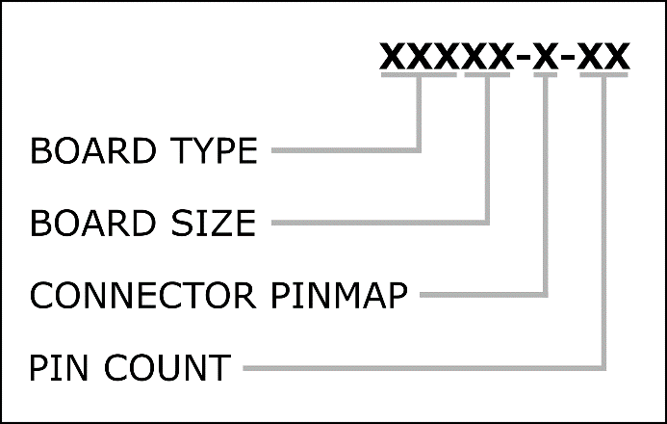

Figure – Board Identification Number

|  |  |  |
| --- | --- | --- |
| MODULE PREFIX | MECHANICAL DIMENSIONS | PINMAP AND PIN COUNT |
| per Section 3.2.1 | per Section 3.2.2 | per Section 3.2.3 |

The remainder of this page intentionally blank.

## BIN Classifications

### Module Prefix

|  |  |
| --- | --- |
| CLASSIFICATION ID | MODULE PREFIX |
| PCB15-X-XX | Circuit device board |
| IDB20-X-XX | Interface device board |

### Mechanical Dimensions

|  |  |
| --- | --- |
| CLASSIFICATION ID | MECHANICAL DIMENSIONS |
| PCB15-X-XX | per Section 4.2 |
| PCB20-X-XX |
| PCB25-X-XX |
| PCB33-X-XX |
| PCB50-X-XX |
| IDA20-X-XX |

### Function and Pinmap

|  |  |  |
| --- | --- | --- |
| CLASSIFICATION ID | FUNCTION AND PIN COUNT | PINMAP |
| XXXXX-A-05 | Analog, 5 pins | Per Section 4.3 |
| XXXXX-A-07 | Analog, 7 pins |
| XXXXX-A-09 | Analog, 9 pins |
| XXXXX-D-05 | Digital, 5 pins |
| XXXXX-D-07 | Digital, 7 pins |
| XXXXX-D-09 | Digital, 9 pins |
| XXX50-D-15 | Digital, 15 pins |
| XXXXX-W-05 | Wild, 5 pins |
| XXXXX-W-07 | Wild, 7 pins |
| XXXXX-W-09 | Wild, 9 pins |
| XXX50-W-15 | Wild, 15 pins |

# Board Design

## Introduction

This section specifies mechanical dimensions, main connectors, and layout features.

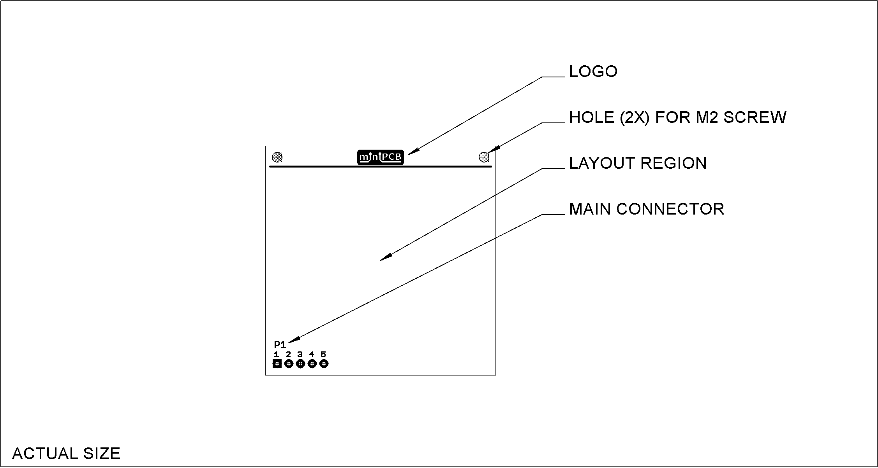

## Mechanical Dimensions

### PCB15

Dimensions are in millimeters.

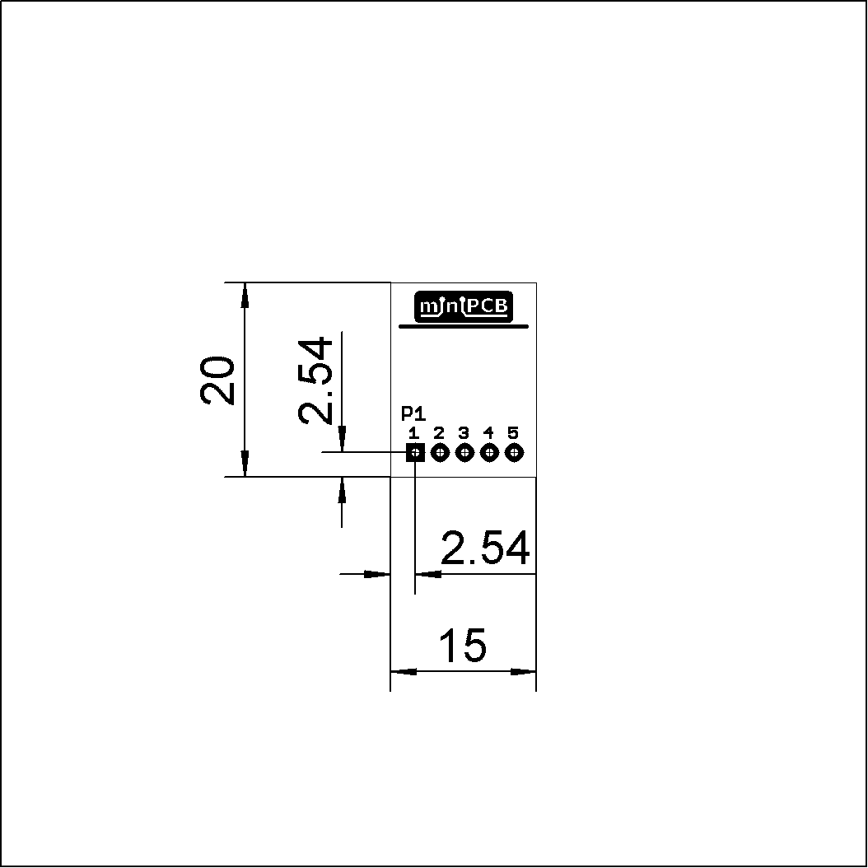

Figure – PCB15-X-05, Mechanical Dimensions

### PCB20

Dimensions are in millimeters.

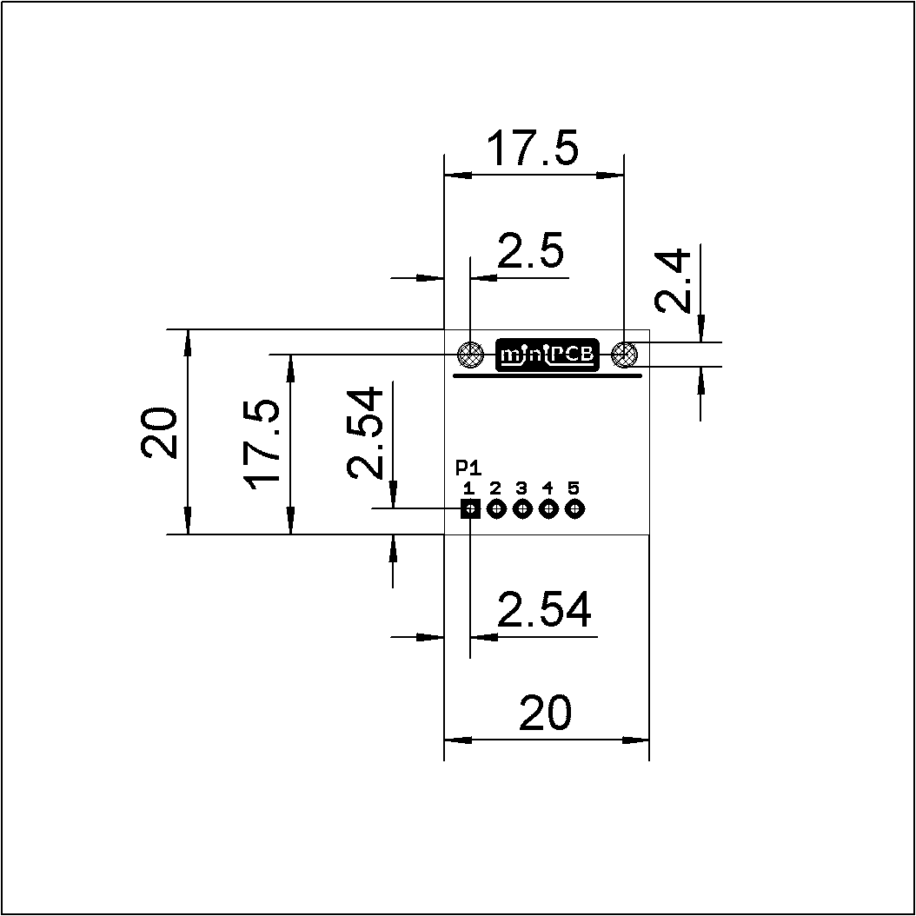

Figure – PCB20-X-05, Mechanical Dimensions

### PCB25

Dimensions are in millimeters.

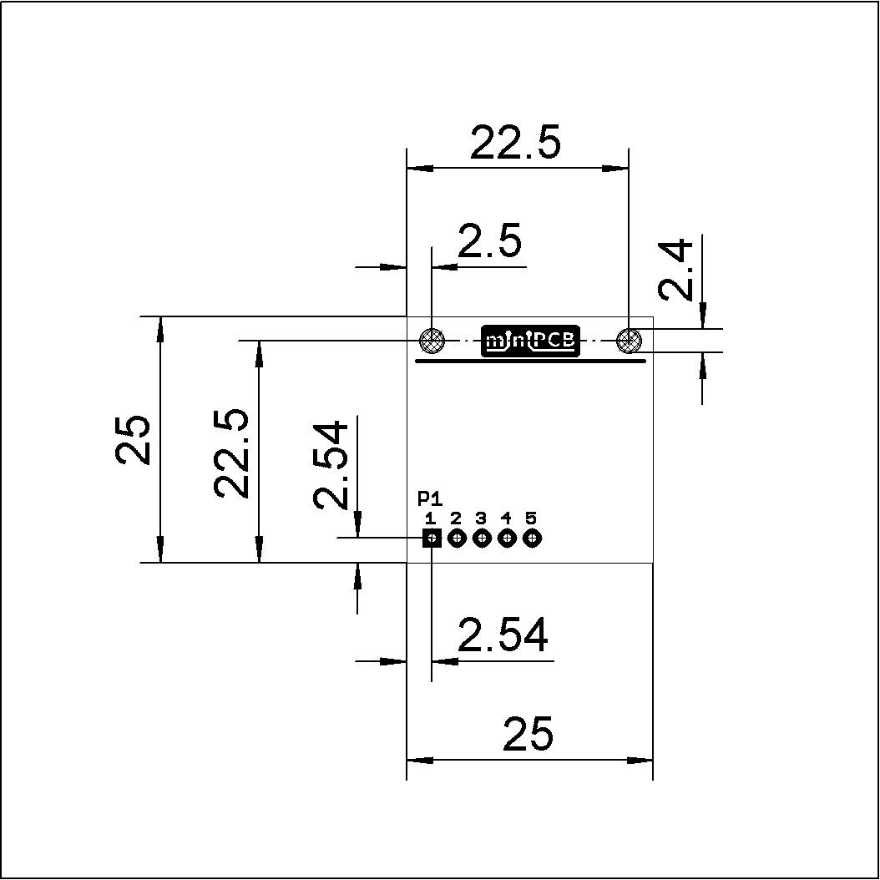

Figure – PCB25-X-05, Mechanical Dimensions

### PCB33

Dimensions are in millimeters.

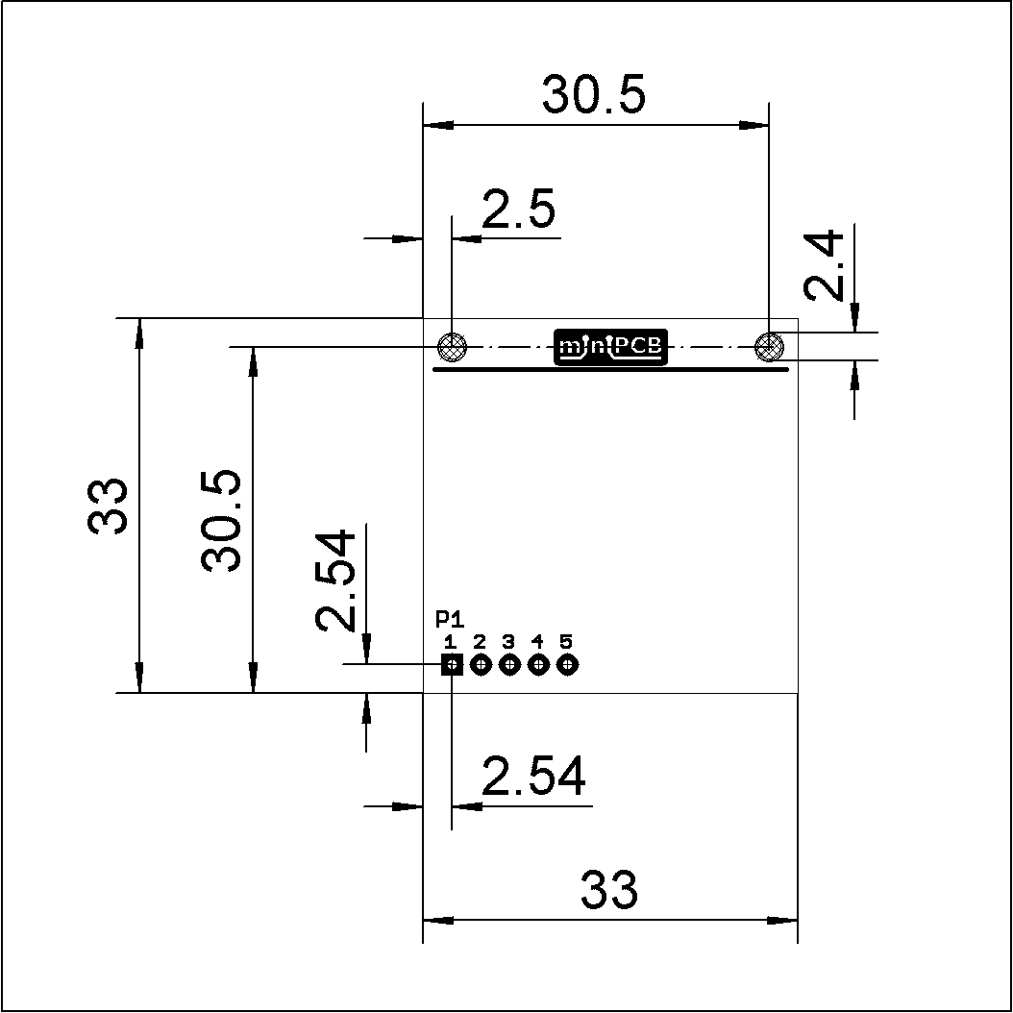

Figure – PCB33-X-05, Mechanical Dimensions

### PCB50

Dimensions are in millimeters.

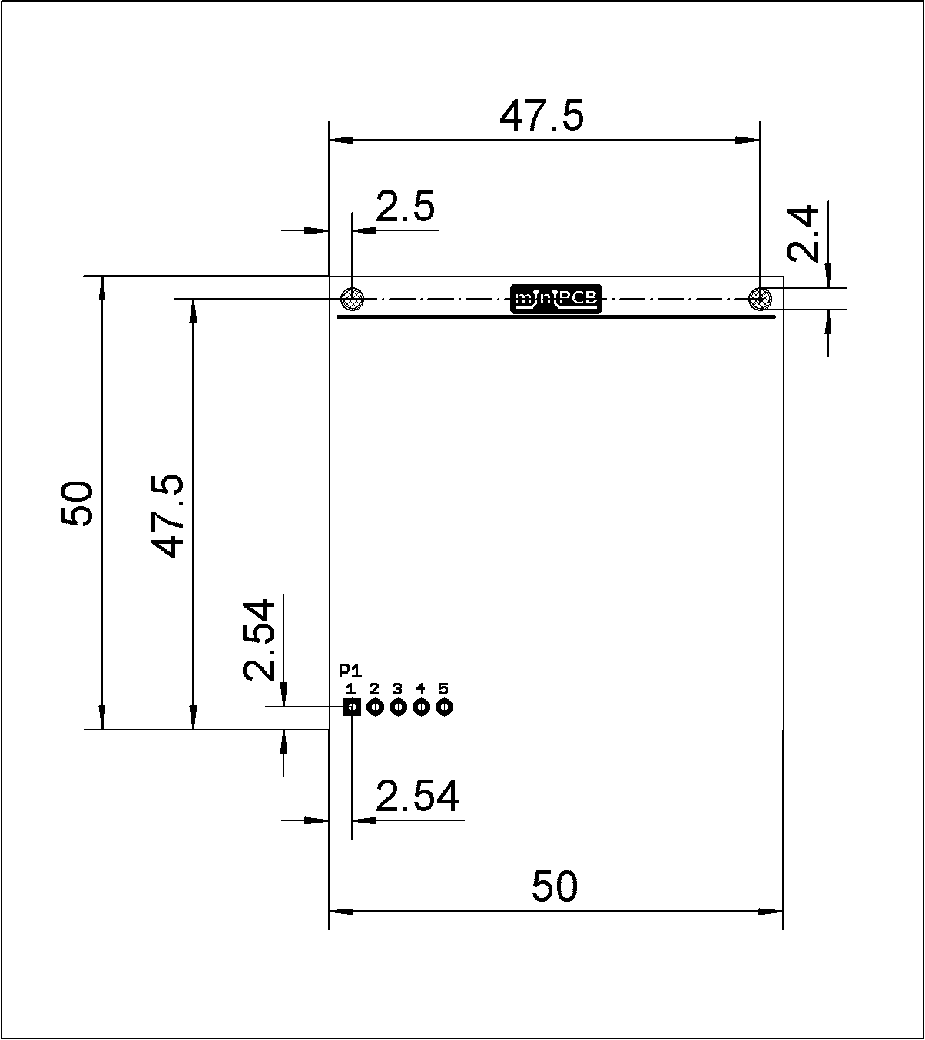

Figure – PCB50-X-05, Mechanical Dimensions

### PCB100/50

Dimensions are in millimeters.

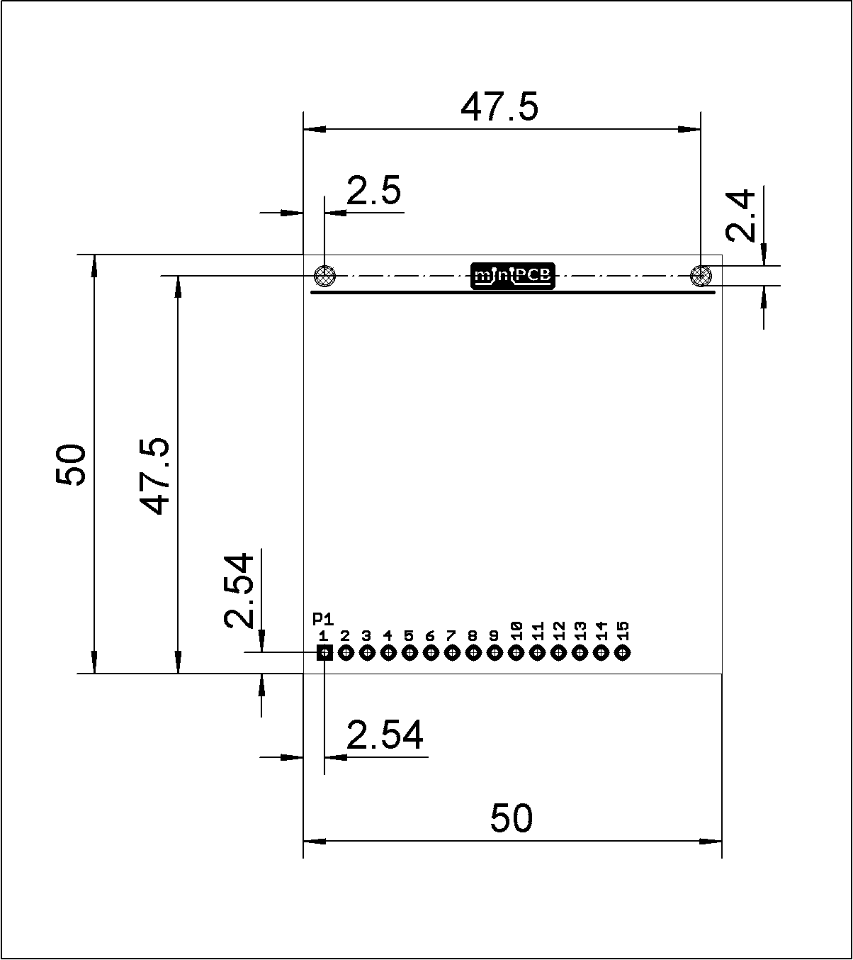

Figure – PCB50-X-15, Mechanical Dimensions

### IDB20

Dimensions are in millimeters.

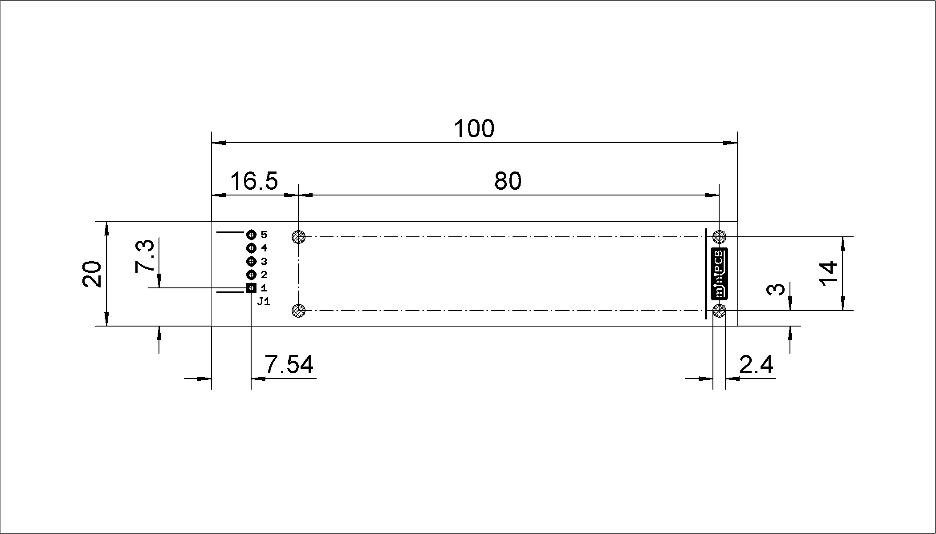

Figure – IDB20-X-05, Mechanical Dimensions

The remainder of this page intentionally blank.

### IDB25

Dimensions are in millimeters.

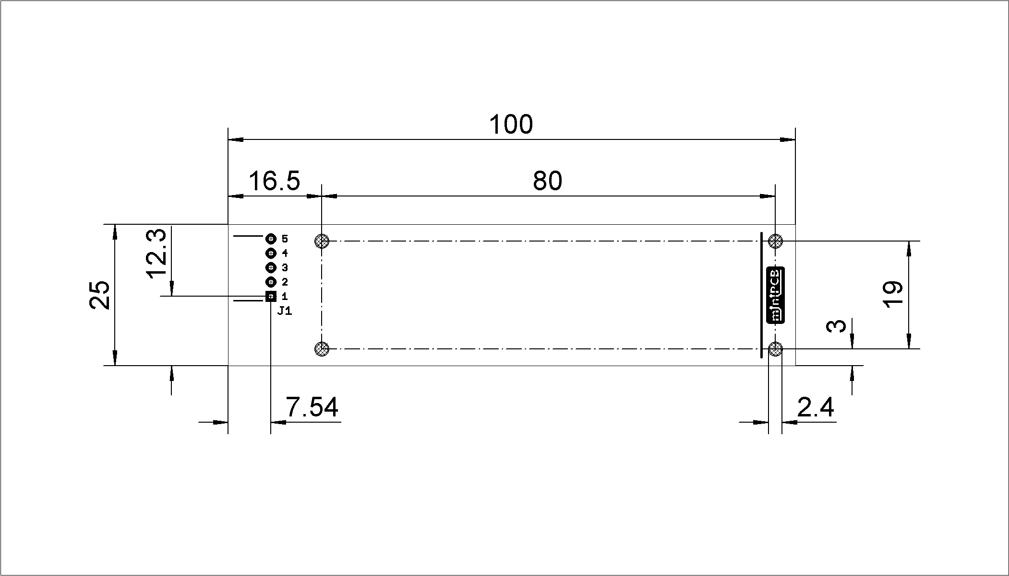

Figure – IDB25-X-05, Mechanical Dimensions

The remainder of this page intentionally blank.

## Main Connector

### Reference Designator

* The reference designator for the main connector is always J1 or P1.
* The prefix “J” is used when the board/cable is intended to be less movable. This is typically the socket, or receptacle, side on the interface device assembly.
* The prefix “P” is used when the board/cable is intended to be more movable. This is typically the pin, or plug, side on the circuit board assembly.

### Parts

* Right-angle orientation is standard; any orientation may be used.
* The part numbers listed here are unique to the miniPCB venture.

#### Pins, P1

|  |  |
| --- | --- |
| PART NUMBER | DESCRIPTION |
| P1-05 | Five (5) contact, plug header, header pins, 0.1” pitch |
| P1-07 | Seven (7) contact, plug header, header pins, 0.1” pitch |
| P1-09 | Nine (9) contact, plug header, header pins, 0.1” pitch |
| P1-15 | Fifteen (15) contact, plug header, header pins, 0.1” pitch |

#### Receptacles, J1

|  |  |
| --- | --- |
| PART NUMBER | DESCRIPTION |
| J1-05 | Five (5) contact, receptacle header, header socket, 0.1” pitch |
| J1-07 | Seven (7) contact, receptacle header, header socket, 0.1” pitch |
| J1-09 | Nine (9) contact, receptacle header, header socket, 0.1” pitch |
| J1-15 | Fifteen (15) contact, receptacle header, header socket, 0.1” pitch |

### Pinmaps

#### Analog, 5 Pin

|  |  |  |  |
| --- | --- | --- | --- |
| PIN | PIN NAME | FUNCTION | NOTES |
| 1 | GND | Ground |  |
| 2 | +V | Supply, DC, Positive | No greater than +60 VDC |
| 3 | -V | Supply, DC, Negative | No greater than -60 VDC |
| 4 | AI+ | Input, Analog |  |
| 5 | AO+ | Output, Analog |  |

The remainder of this page intentionally blank.

#### Analog, 7 Pin

|  |  |  |  |
| --- | --- | --- | --- |
| PIN | PIN NAME | FUNCTION | NOTES |
| 1 | GND | Ground |  |
| 2 | +V | Supply, DC, Positive | No greater than +60 VDC |
| 3 | -V | Supply, DC, Negative | No greater than -60 VDC |
| 4 | AI1+ | Input, Analog |  |
| 5 | AO1+ | Output, Analog |  |
| 6 | AI2+ | Input, Analog |  |
| 7 | AO2+ | Output, Analog |  |

The remainder of this page intentionally blank.

#### Analog, 9 Pin

|  |  |  |  |
| --- | --- | --- | --- |
| PIN | PIN NAME | FUNCTION | NOTES |
| 1 | GND | Ground |  |
| 2 | +V | Supply, DC, Positive | No greater than +60 VDC |
| 3 | -V | Supply, DC, Negative | No greater than -60 VDC |
| 4 | AI1+ | Input, Analog |  |
| 5 | AO1+ | Output, Analog |  |
| 6 | AI2+ | Input, Analog |  |
| 7 | AO2+ | Output, Analog |  |
| 8 | AI3+ | Input, Analog |  |
| 9 | AO3+ | Output, Analog |  |

The remainder of this page intentionally blank.

#### Digital, 5 Pin

|  |  |  |  |
| --- | --- | --- | --- |
| PIN | PIN NAME | FUNCTION | NOTES |
| 1 | GND | Ground |  |
| 2 | +V | Supply, DC, Positive | No greater than +60 VDC |
| 3 | -V | Supply, DC, Negative | No greater than -60 VDC |
| 4 | * | * | Digital signal |
| 5 | * | * | Digital signal |

*Defined on an individual basis in respective datasheets.

The remainder of this page intentionally blank.

#### Digital, 7 Pin

|  |  |  |  |
| --- | --- | --- | --- |
| PIN | PIN NAME | FUNCTION | NOTES |
| 1 | GND | Ground |  |
| 2 | +V | Supply, DC, Positive | No greater than +60 VDC |
| 3 | -V | Supply, DC, Negative | No greater than -60 VDC |
| 4 | * | * | Digital signal |
| 5 | * | * | Digital signal |
| 6 | * | * | Digital signal |
| 7 | * | * | Digital signal |

*Defined on an individual basis in respective datasheets.

The remainder of this page intentionally blank.

#### Digital, 9 Pin

|  |  |  |  |
| --- | --- | --- | --- |
| PIN | PIN NAME | FUNCTION | NOTES |
| 1 | GND | Ground |  |
| 2 | +V | Supply, DC, Positive | No greater than +60 VDC |
| 3 | -V | Supply, DC, Negative | No greater than -60 VDC |
| 4 | * | * | Digital signal |
| 5 | * | * | Digital signal |
| 6 | * | * | Digital signal |
| 7 | * | * | Digital signal |
| 8 | * | * | Digital signal |
| 9 | * | * | Digital signal |

*Defined on an individual basis in respective datasheets.

The remainder of this page intentionally blank.

#### Digital, 15 Pin

|  |  |  |  |
| --- | --- | --- | --- |
| PIN | PIN NAME | FUNCTION | NOTES |
| 1 | GND | Ground |  |
| 2 | +V | Supply, DC, Positive | No greater than +60 VDC |
| 3 | -V | Supply, DC, Negative | No greater than -60 VDC |
| 4 | * | * | SPI.MOSI, I2C.SDA, UART.P1.RX |
| 5 | * | * | SPI.SCK, I2C.SCL, UART.P1.TX |
| 6 | * | * | SPI.MISO |
| 7 | * | * | SPI.CS |
| 8 | D0 | Digital input output, bit 0 (lsb) | Least significant bit |
| 9 | D1 | Digital input output, bit 1 |  |
| 10 | D2 | Digital input output, bit 2 |  |
| 11 | D3 | Digital input output, bit 3 |  |
| 12 | D4 | Digital input output, bit 4 |  |
| 13 | D5 | Digital input output, bit 5 |  |
| 14 | D6 | Digital input output, bit 6 |  |
| 15 | D7 | Digital input output, bit 7 (msb) | Most significant bit |

*Defined on an individual basis in respective datasheets.

The remainder of this page intentionally blank.

#### WILD, 5 Pin

|  |  |  |  |
| --- | --- | --- | --- |
| PIN | PIN NAME | FUNCTION | NOTES |
| 1 | GND | Ground |  |
| 2 | +V | Supply, DC, Positive | No greater than +60 VDC |
| 3 | -V | Supply, DC, Negative | No greater than -60 VDC |
| 4 | * | * | Analog or digital |
| 5 | * | * | Analog or digital |

*Defined on an individual basis in respective datasheets.

The remainder of this page intentionally blank.

#### WILD, 7 Pin

|  |  |  |  |
| --- | --- | --- | --- |
| PIN | PIN NAME | FUNCTION | NOTES |
| 1 | GND | Ground |  |
| 2 | +V | Supply, DC, Positive | No greater than +60 VDC |
| 3 | -V | Supply, DC, Negative | No greater than -60 VDC |
| 4 | * | * | Analog or digital |
| 5 | * | * | Analog or digital |
| 6 | * | * | Analog or digital |
| 7 | * | * | Analog or digital |

*Defined on an individual basis in respective datasheets.

The remainder of this page intentionally blank.

#### WILD, 9 Pin

|  |  |  |  |
| --- | --- | --- | --- |
| PIN | PIN NAME | FUNCTION | NOTES |
| 1 | GND | Ground |  |
| 2 | +V | Supply, DC, Positive | No greater than +60 VDC |
| 3 | -V | Supply, DC, Negative | No greater than -60 VDC |
| 4 | * | * | Analog or digital |
| 5 | * | * | Analog or digital |
| 6 | * | * | Analog or digital |
| 7 | * | * | Analog or digital |
| 8 | * | * | Analog or digital |
| 9 | * | * | Analog or digital |

*Defined on an individual basis in respective datasheets.

The remainder of this page intentionally blank.

#### WILD, 15 Pin

|  |  |  |  |
| --- | --- | --- | --- |
| PIN | PIN NAME | FUNCTION | NOTES |
| 1 | GND | Ground |  |
| 2 | +V | Supply, DC, Positive | No greater than +60 VDC |
| 3 | -V | Supply, DC, Negative | No greater than -60 VDC |
| 4 | * | * | Analog or digital |
| 5 | * | * | Analog or digital |
| 6 | * | * | Analog or digital |
| 7 | * | * | Analog or digital |
| 8 | * | * | Analog or digital |
| 9 | * | * | Analog or digital |
| 10 | * | * | Analog or digital |
| 11 | * | * | Analog or digital |
| 12 | * | * | Analog or digital |
| 13 | * | * | Analog or digital |
| 14 | * | * | Analog or digital |
| 15 | * | * | Analog or digital |

*Defined on an individual basis in respective datasheets.

The remainder of this page intentionally blank.

## Board Layout

### Component Placement

As possible, components will be placed on the top (logo) side of the board and reference designators will be placed next to component outlines. Reference designators will be formatted similar to these settings:

Table – Reference Designator Properties

|  |  |
| --- | --- |
| PROPERTY | SETTING |
| Font | Vector |
| Font Size | 1.5 mm |
| Font Width | 12% |
| Layer | tNames  bNames |

### Through Hole Device (THD) Layouts

As possible for Through Hole Device (THD) miniPCBs, traces will be routed on the bottom (part number) side of the board and the ground plane on the top side will remain as “uncut” as possible to provide an optimal ground plane return path.

Table – Layout Rules, THD

|  |  |  |  |
| --- | --- | --- | --- |
| PROPERTY | MIN | TYP | MAX |
| Trace width | 0.3 mm | 0.4 mm | 0.5 mm |
| Via drill diameter | 0.3 mm | 0.5 mm |  |
| Grid for component placement | 0.5 mm | 1 mm |  |
| Edge keepout | 1 mm | 1.5 mm |  |

### Surface Mount Device (SMD) Layouts

As possible for Surface Mount Device (SMD) miniPCBs, traces will be routed on the top (logo) side of the board and the ground plane on the bottom side will remain as “uncut” as possible to provide an optimal ground plane return path.

Table – Layout Rules, SMD

|  |  |  |  |
| --- | --- | --- | --- |
| PROPERTY | MIN | TYP | MAX |
| Trace width | 0.2 mm | 0.3 mm | 0.4 mm |
| Via drill diameter | 0.3 mm | 0.5 mm |  |
| Grid for component placement | 0.1 mm | 1 mm |  |
| Edge keepout | 1 mm | 1.5 mm |  |

### Mixed Device (THD, SMD) Layouts

As possible for mixed device miniPCBs, THD components will be placed on the logo-side of the board, SMD components will be placed on the part-number-side of the board, traces will be routed on the part-number-side of the board, and the ground plane on the logo-side of the board will remain as “uncut” as possible to provide an optimal ground plane return path.

### Test Points

Test points will be included when they are needed to test or adjust the circuit.

### Part Number

A part number will be placed on the bottom side of the board, in the region furthest away from the main connector. The part number will be placed in both copper and silkscreen.

### Logo

A logo will be placed on the top side of the board, in the region furthest away from the main connector. The logo will be placed in copper and exposed by the soldermask.

# Enclosure Design

## Introduction

This section specifies common design parameters for enclosure designs.

## Fasteners

|  |  |  |  |
| --- | --- | --- | --- |
| FASTENER |  |  | CLEARANCE HOLE |
|  |  |  |  |
|  |  |  |  |
|  |  |  |  |
|  |  |  |  |

# Part Identification Number

## Introduction

This section specifies the Part Identification Number (PIN). The PIN provides information concerning the part’s circuit, component sizes, and miniPCB revision.

The PIN is in the following form:

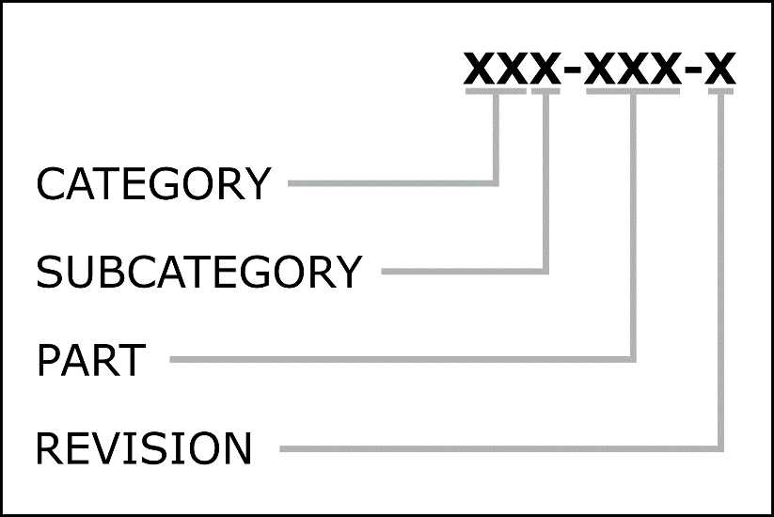

Figure – Part Identification Number

|  |  |  |  |
| --- | --- | --- | --- |
| CATEGORY | SUBCATEGORY | PART | REVISION |
| per Section 5.2.1 | per Section 5.2.2 | per Section 5.2.3 | per Section 5.2.4 |

The remainder of this page intentionally blank.

## PIN Classifications

### Category

Categories are identified by two (2) digits.

|  |  |  |
| --- | --- | --- |
| CLASSIFICATION ID | TITLE | DESCRIPTION |
| 00X-XXX-X | Test Boards | PCBs that enable electronic test setups |
| 01X-XXX-X | Components | PCBs that enable component test setups |
| 02X-XXX-X | Sensors | PCBs with layouts of sensing circuits |
| 03X-XXX-X | Actuators | PCBs with layouts of actuator circuits |
| 04X-XXX-X | Amplifiers | PCBs with layouts of amplifier circuits |
| 05X-XXX-X | Filters | PCBs with layouts of filter circuits |
| 06X-XXX-X | Oscillators | PCBs with layouts of oscillators |
| 07X-XXX-X | Radio | PCBs with layouts of radio frequency circuits |
| 08X-XXX-X | Signal Converters | PCBs with layouts of signal converter circuits |
| 09X-XXX-X | Power | PCBs with layouts of power circuits |
| 10X-XXX-X | Digital | PCBs with layouts of digital circuits |
| 11X-XXX-X | Computing | PCBs with layouts of computer circuits |
| 12X-XXX-X | Communication | PCBs with layouts of communication circuits |
| 13X-XXX-X | Games | PCBs with layouts for game circuits |
| 14X-XXX-X | Languages | Machine code |
| 15X-XXX-X | Programs | Firmware repository |

### Subcategory

Subcategories are identified by a single letter. Each subcategory can hold up to two hundred (200) unique circuits. Categories and subcategories will be added as more circuits are desired.

#### Test Boards, 00

* 00A, Probe and prototyping
* 00B; Test device and setup boards
* 00C; Signal generation and acquisition boards

#### Components, 01

* 01A; Discrete Components
* 01B; Integrated Components
* 01C; Modular Components

#### Sensors, 02

* 02A; Human interface
* 02B; Environment interface
* 02C; Machine interface

#### Actuators, 03

* 03A; Mechanical
* 03B; Thermal
* 03C; Photic

#### Amplifiers, 04

* 04A; Operational amplifiers
* 04B; Transistor amplifiers
* 04C; Application specific amplifiers

#### Filters, 05

* 05A; Passive
* 05B; Active

#### Oscillators, 06

* 06A; Harmonic (Linear)
* 06B; Relaxation (Nonlinear)

#### Radio, 07

* 07A; Transmitters
* 07B; Receivers
* 07C; Transceivers

#### Signal Converters, 08

* 08A; Analog to Digital
* 08B; Digital to Analog
* 08C; Voltage to Current
* 08D; Current to Voltage
* 08E; Voltage to Frequency
* 08F; Frequency to Voltage
* 08G; Time to Voltage

#### Power, 09

* 09A; Voltage limiters, references, regulators
* 09B; Current limiters, mirrors, regulators
* 09C; Power converters, isolators
* 09D; Fuses, rectifiers, filters, transformers
* 09E; RESERVED
* 09F; Optoisolators

#### Digital, 10

* 10A; Logic Gates
* 10B; Logic Devices (clocks, registers, flip-flops, etc.)
* 10C; Digital Systems

#### Computing, 11

* 11A; Math
* 11B; Processors
* 11C; Learning Machines

#### Communication, 12

* 12A; Wired
* 12B; Wireless Radio
* 12C; Wireless Optical

#### GAMES, 13

* 13A; Luck Games (i.e. chance)
* 13B; Computation Games (i.e. strategy)
* 13C; Empathy Games (i.e. bluffing)

### Part

Each circuit is allotted five (5) part numbers, 0-4 or 5-9, to allow for different layouts with various component sizes.

|  |  |  |
| --- | --- | --- |
| CLASSIFICATION ID | TITLE | DESCRIPTION |
| XXX-XX0-X | THD | Layout uses through hole device components. |
| XXX-XX1-X | SMD, 1206 | Layout uses 1206 surface mount device components |
| XXX-XX2-X | SMD, 0805 | Layout uses 0805 surface mount device components |
| XXX-XX3-X | SMD, 0402 | Layout uses 0402 surface mount device components |
| XXX-XX4-X | RESERVED | Reserved for future use. |
| XXX-XX5-X | THD | Layout uses through hole device components. |
| XXX-XX6-X | SMD, 1206 | Layout uses 1206 surface mount device components |
| XXX-XX7-X | SMD, 0805 | Layout uses 0805 surface mount device components |
| XXX-XX8-X | SMD, 0402 | Layout uses 0402 surface mount device components |
| XXX-XX9-X | RESERVED | Reserved for future use. |

### Revision Identification

Revisions of documents will be identified in their filenames.

|  |  |  |
| --- | --- | --- |
| FILENAME | RELEASE STATUS | DESCRIPTION |
| XXX-XXX | NOT RELEASED | Living/working file |
| XXXX-XXX-A | Prototype Release | Released prototype revision. |
| XXX-XXX-A | Initial Release | Released product revision. |

# Engineering Documentation

## Introduction

This section specifies features of controlled documents such as schematics, datasheets, procedures, forms, and reports.

## Document Control

### Revision History

Revisions will increment from A to B, C, D, etc.

Documents created in a CAD tool will have a revision history table similar to this:

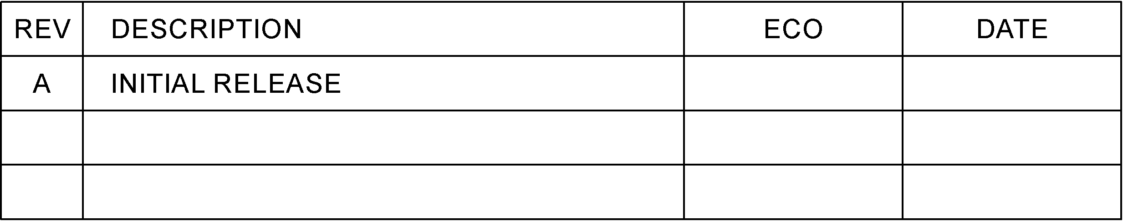

Figure – Exemplar Revision History Table

Documents created in Microsoft Word will have a revision history table similar to this:

Table – Exemplar Revision History Table

|  |  |  |  |
| --- | --- | --- | --- |
| REV | DESCRIPTION | ECO | DATE |
| A | Initial Release | ### | DDMMMYYYY |
|  |  |  |  |

### Review and Approval

Engineering documentation will be reviewed, approved, and signed by a qualified engineer prior to release.

### Electronic Signatures

Documents created in CAD tools will be signed electronically within the CAD tool.

Documents created in Microsoft Office will be signed electronically within Microsoft Office.

Video records of hardware releases will be available on the miniPCB Channel on YouTube.

### Engineering Change Orders

A description of approved changes to engineering documentation will be recorded on an Engineering Change Order (ECO) form.

### Engineering Records

|  |  |
| --- | --- |
| RECORD | DESCRIPTION |
| Source Files | Gerbers, CAD files, Word documents, Excel documents, etc. |
| Schematics | PDF document (from CAD) |
| Datasheets | PDF document (from Word) |
| FMEA Reports | PDF document |
| Testing Procedure | PDF document |
| Testing Report | PDF document |
| Engineering Change Orders | PDF documents |

### File Repository

Engineering files and records will be saved in a GitHub repository owned by Nolan Manteufel.

### Public Disemination

Engineering files and records will be published to a public GitHub repository owned by Nolan Manteufel. Current and obsolete revisions will be available according to GitHub file version history capabilities.

Table – GitHub Repository

|  |  |
| --- | --- |
| REPOSITORY | LOCATION |
| GitHub | https://github.com/miniPCB |

## Schematics

### Pin Names for J1 and P1

Used pins will be labeled with pin names. Unused pins will be labeled with “NO CONNECT”.

### Parts List

Include a parts list table with these columns:

* FIND NO
* REF DES
* COMPONENT
* PACKAGE
* PINOUT
* COMMENTS

The remainder of this page intentionally blank.

### Sheets

#### miniPCB Size A, Horizontal

Dimensions are in millimeters.



Figure – miniPCB Size A, Horizontal

#### miniPCB Size A Continued, Horizontal

Dimensions are in millimeters.



Figure – miniPCB Size A Continued, Horizontal

#### miniPCB Size A, Vertical

Dimensions are in millimeters.



Figure – miniPCB Size A, Vertical

#### miniPCB Size A Continued, Vertical

Dimensions are in millimeters.



Figure – miniPCB Size A Continued, Vertical

#### miniPCB Size A Experimental, Vertical

Dimensions are in millimeters.

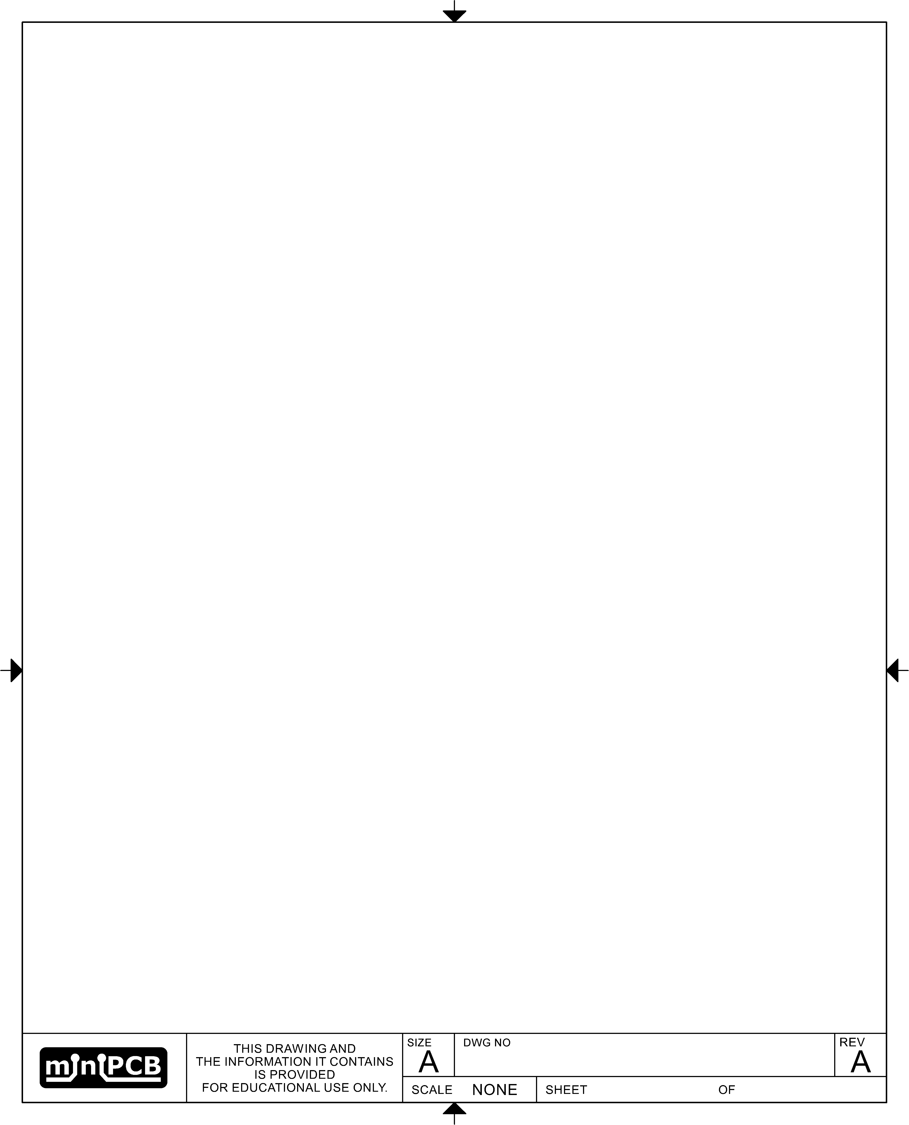

Figure – miniPCB Size A Experimental, Vertical

#### miniPCB Part Specification

Dimensions are in millimeters.

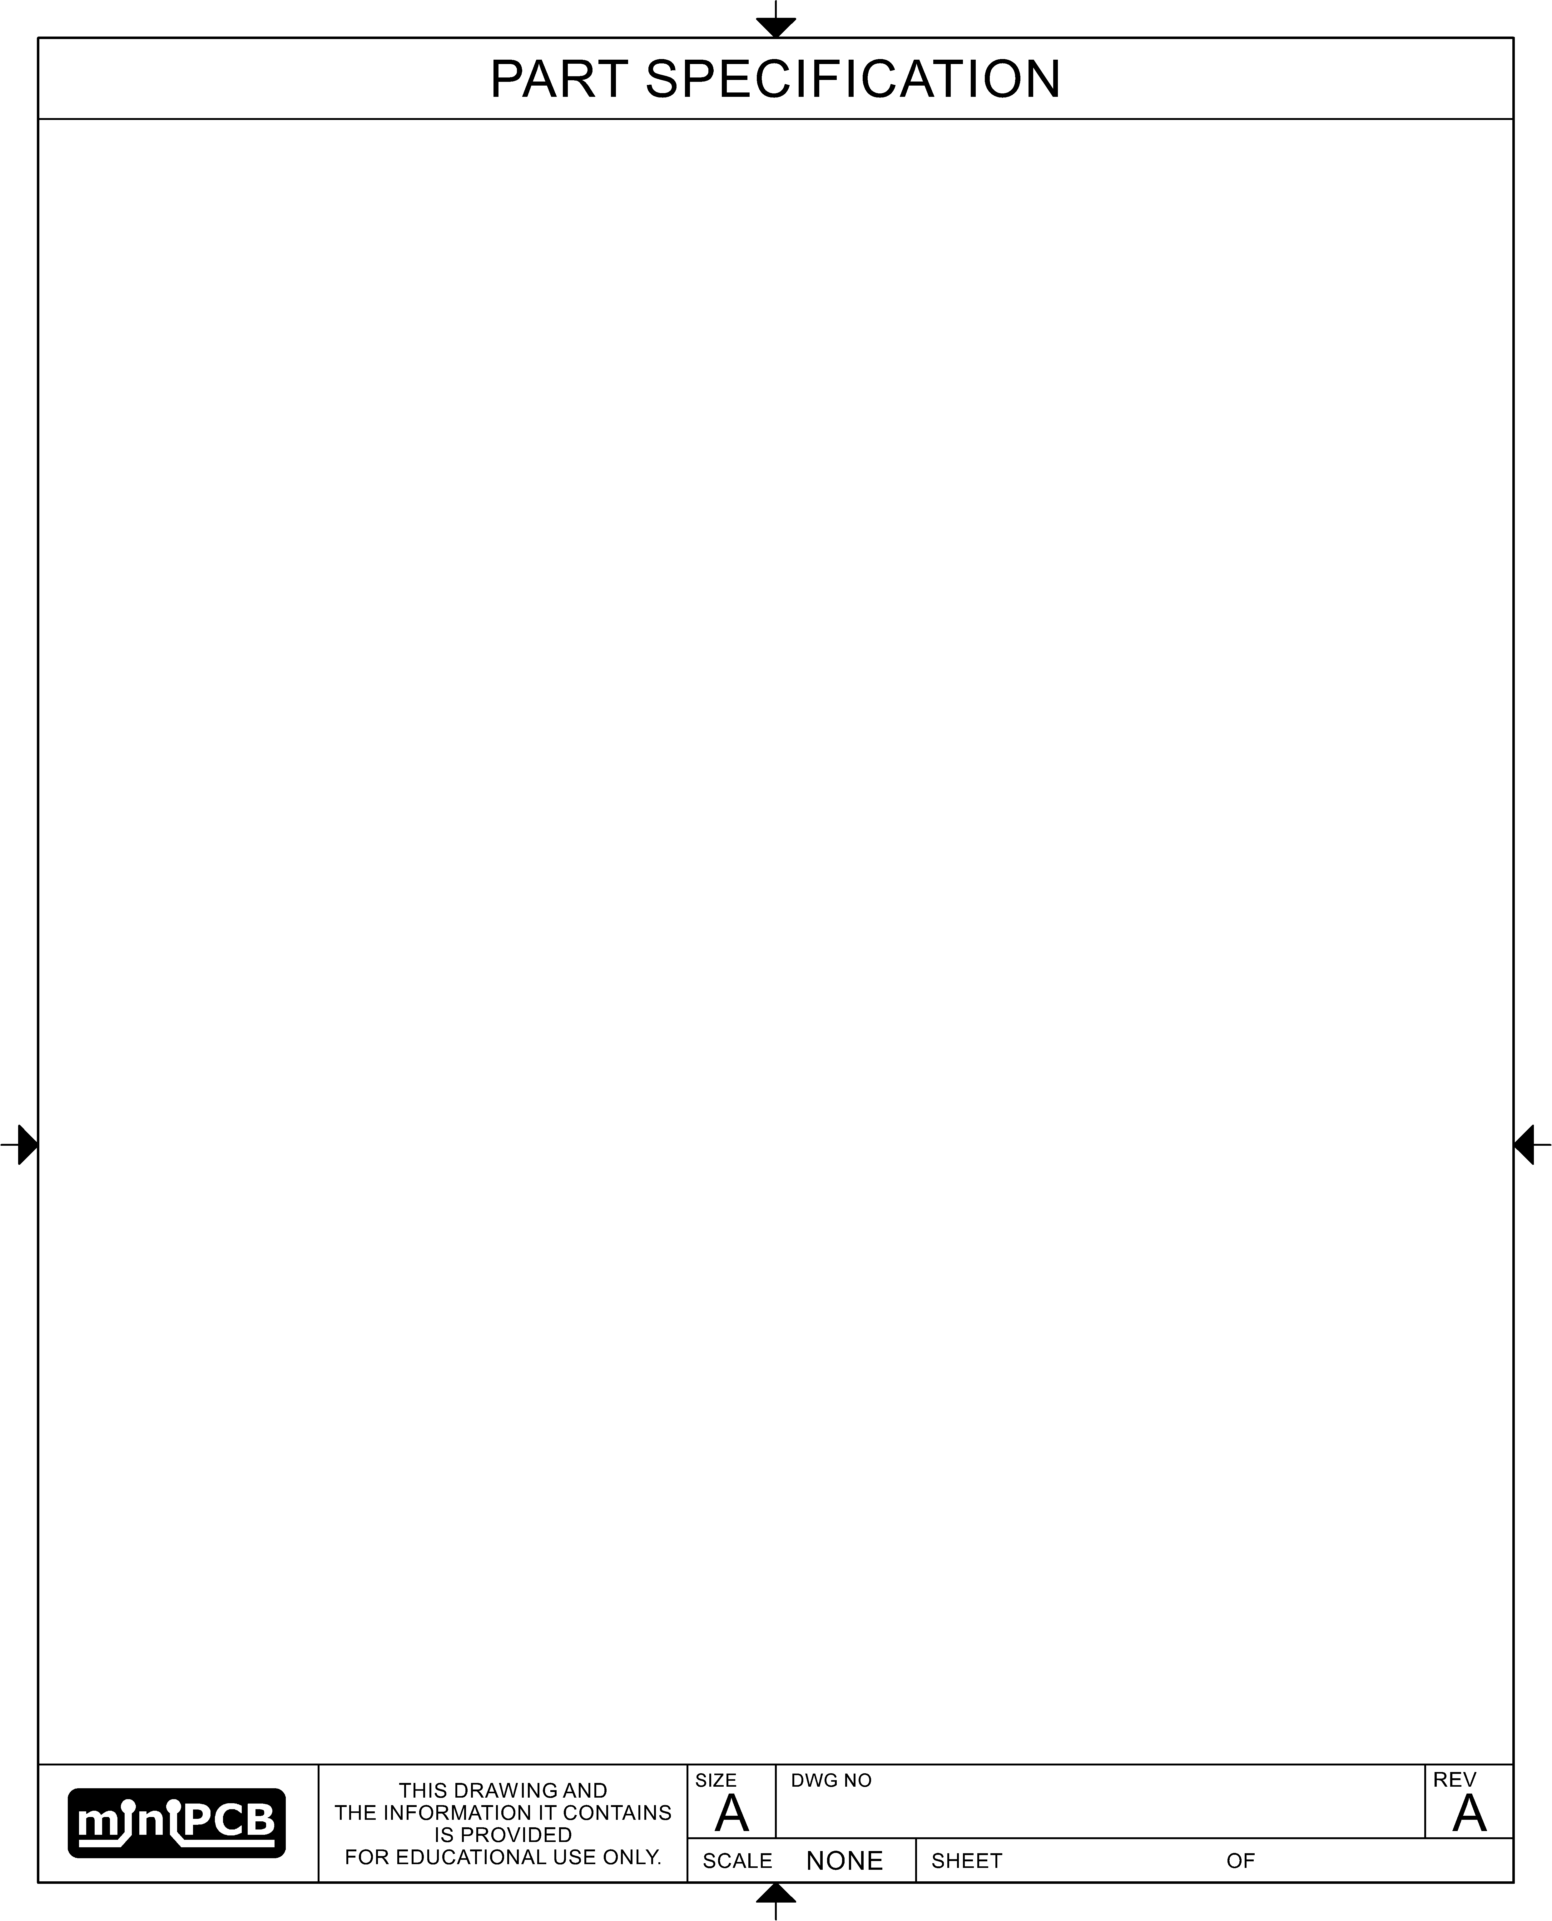

Figure – miniPCB Part Specification

#### miniPCB Size B, Horizontal

Dimensions are in millimeters.



Figure – miniPCB Size B, Horizontal

#### miniPCB Size B Continued, Horizontal

Dimensions are in millimeters.



Figure – miniPCB Size B Continued, Horizontal

### Component Symbols

Need to develop EAGLE library parts and place an image of each symbol here.

### Component Footprints

This section specifies component footprints and pinouts.

#### General Rules

Table – General Component Footprint Rules

|  |  |
| --- | --- |
| PROPERTY | SETTING |
| Font | Vector |
| Font Size | 1.5 mm |
| Font Width | 12% |
| Name Layers | tNames, 25 |
| Outline Layer | tPlace, 21 |
| Outline Silkscreen | 0.2 mm |

#### Footprints

| NAME | FOOTPRINTS | PINOUTS |
| --- | --- | --- |
| NM-R0805 |  |  |
| NM-SOT23-3 |  |  |
| NM-SOIC16-300 |  |  |

### Component Reference Designators

Use reference designators per this list.

| REF. DES. | COMPONENT |
| --- | --- |
| A | Gyroscope  Computational device such as adder, subtractor, multiplier, divider, integrator, differentiator  Sensor device that transduces to electric power |
| AR | Amplifier  Repeater |
| AT | Attenuator  Fixed attenuator  Variable attenuator |
| B | Button Switch  Blower  Fan  Fan motor |
| BT | Battery  Photovoltaic transducer |
| C | Capacitor |
| CB | Circuit breaker  Network protector |
| CP | Connector adaptor  Conductor junction |
| CR | Current regulator |
| D | Diode  Zener diode  Photodiode |
| D or CR | Crystal diode |
| D or VR | Breakdown-diode (voltage regulator) |
| DC | Directional coupler |
| DL | Delay line  Delay function |
| DS | Display device |
|  | THIS CELL INTENTIONALLY BLANK |
| E | Antenna  Armature  Binding post  Carbon block  Circuit terminal  Conductivity cell  Electrolytic cell |
| EQ | Equalizing network |
| F | Fuse  Fuse breaker |
| FL | Filter |
| G | Circuit oscillator  Electric generator |
| H | Hardware such as common fasteners |
| HP | Hydraulic part |
| HR | Heater |
| HS | Handset |
| HT | Earphone |
| HW | Human interface device, wearable |
| HX | Human interface device not described by **HS**, **HT**, or **HW** |
| J | Plug, stationary portion connector |
| K | Relay  Contactor |
| L | Inductor  Coil  Solenoid  Winding |
| LED | Light emitting diode |
| LS | Audible alarm  Buzzer  Loudspeaker |
| M | Meter  Oscilloscope  Instrument |
| MG | Electric motor |
| MK | Microphone |
| MP | Mechanical part  Brake  Clutch  Lock |
| MT | Measurement transducer  Primary detector |
| P | Plug, movable portion connector |
| PS | Power supply |
| Q | Transistor |
| R | Resistor  Potentiometer  Shunt |
| RT | Thermistor  Thermal resistor |
| S | Switch  Contactor |
| T | Transformer |
| TB | Test block  Terminal board |
| TP | Test point |
| U | Integrated circuit  Photo-isolator |
| VR | Voltage regulator  Voltage regulator integrated circuit  Voltage regulator module |
| W | Cable  Wire  Conductor  Transmission path |
| WT | Wiring tie point |
| X | Fuse holder  Socket |
| Y | Crystal oscillator  Crystal resonator |

## Datasheets

### Board Views

Include board views of the top and bottom sides. If test points are present, include dimensions to each test point.

### Connector Pinmaps

For each connector, include a pinmap table similar to this:

Table – Exemplar Pinmap Table

|  |  |  |  |
| --- | --- | --- | --- |
| PIN | PIN NAME | FUNCTION | NOTE |
| 1 | GND | Ground |  |
| 2 | +V | DC Supply, Positive | Limited by component ratings |
| 3 | NC | No Connect |  |
| 4 | AI+ | Analog input | AC coupled |
| 5 | AO+ | Analog output | DC coupled |

### Component Pinouts

For components with pinouts that need to be known during component selection, include a pinout table similar to this:

Table – Exemplar Pinout Table

|  |  |  |
| --- | --- | --- |
| PIN | PIN NAME | FOOTPRINT (TOP VIEW) |
| 1 |  |  |
| 2 |  |
| 3 |  |
| 4 |  |
| 5 |  |
| 6 |  |
| 7 |  |
| 8 |  |

### Parts List

Include a parts list table similar to this:

Table – Exemplar Parts List

|  |  |  |  |  |  |
| --- | --- | --- | --- | --- | --- |
| FIND | REF. DES. | COMPONENT | FOOTPRINT | PART VALUE | COMMENTS |
| 1 | R1 | Resistor | 0805 |  |  |
| 2 | R2 | Resistor | 0805 |  |  |
| 3 | R3 | Resistor | 0805 |  |  |
| 4 | C1 | Capacitor | 0805 |  |  |
| 5 | C2 | Capacitor | 0805 |  |  |
| 6 | C3 | Capacitor | 0805 |  |  |
| 7 | Q1 | Transistor | SOT-23 |  | Pinout (123: BEC|GSD) |
| 8 | P1 | Header Pins | 5-pin |  |  |

The remainder of this page intentionally blank.

# Board Fabrication

## Introduction

This section specifies manufacturing options and panels.

## Manufacturing Options

Table – PCB Manufacturing Options

|  |  |
| --- | --- |
| PCB PROPERTY | SETTING |
| Board Material | FR4 / Tg130 |
| Number of Layers | 2 |
| Board Thickness | 1.6 mm |
| PCB Color | Green |
| Surface Finish | HASL |
| Copper Weight | 1 oz. |
| Minimum Hole Size | 0.3 mm |
| Trace Width Spacing | 6/6 mil |

Table – Stencil Manufacturing Options

|  |  |
| --- | --- |
| STENCIL PROPERTY | SETTING |
| Thickness | 0.12 mm |
| Polishing Technique | Polished |

## Panels

miniPCBs will be panelized so that they are within 100 x 100 mm overall dimensions and can be v-scored.

### PCB15-X-05 Panel

Dimensions are in millimeters.

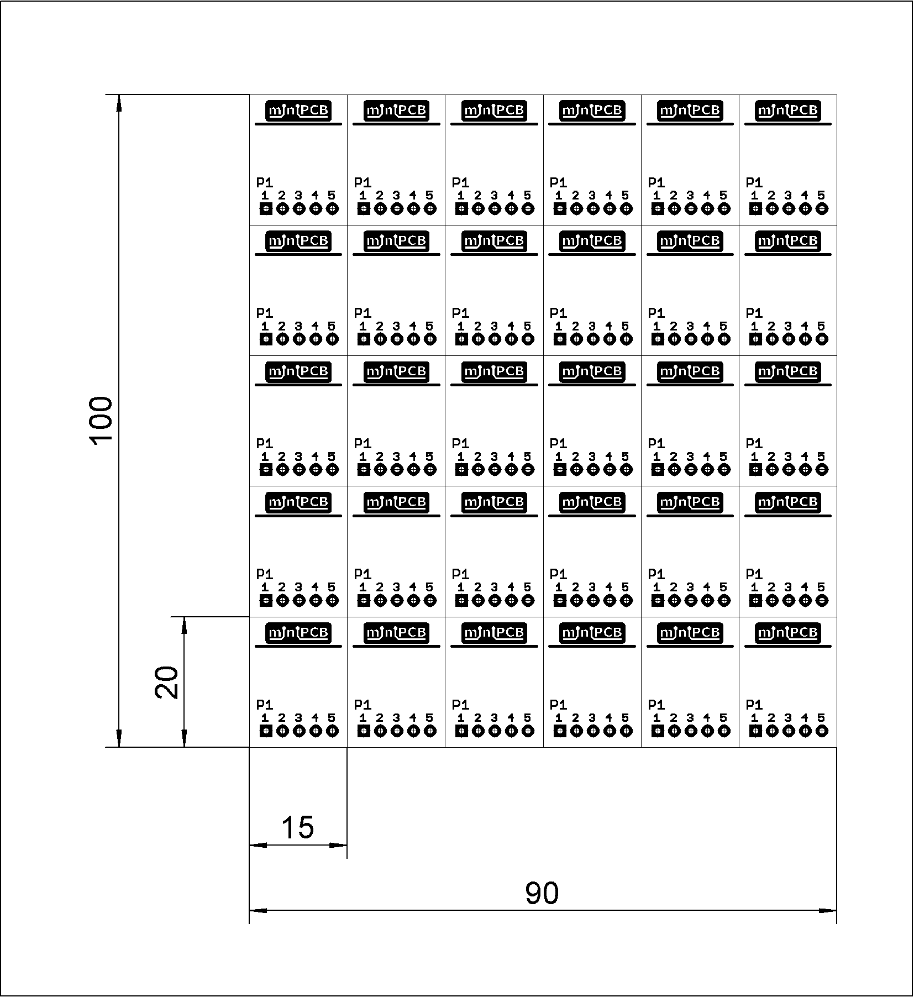

Figure – PCB15-X-05 Panel

### PCB20-X-XX Panel

Dimensions are in millimeters.

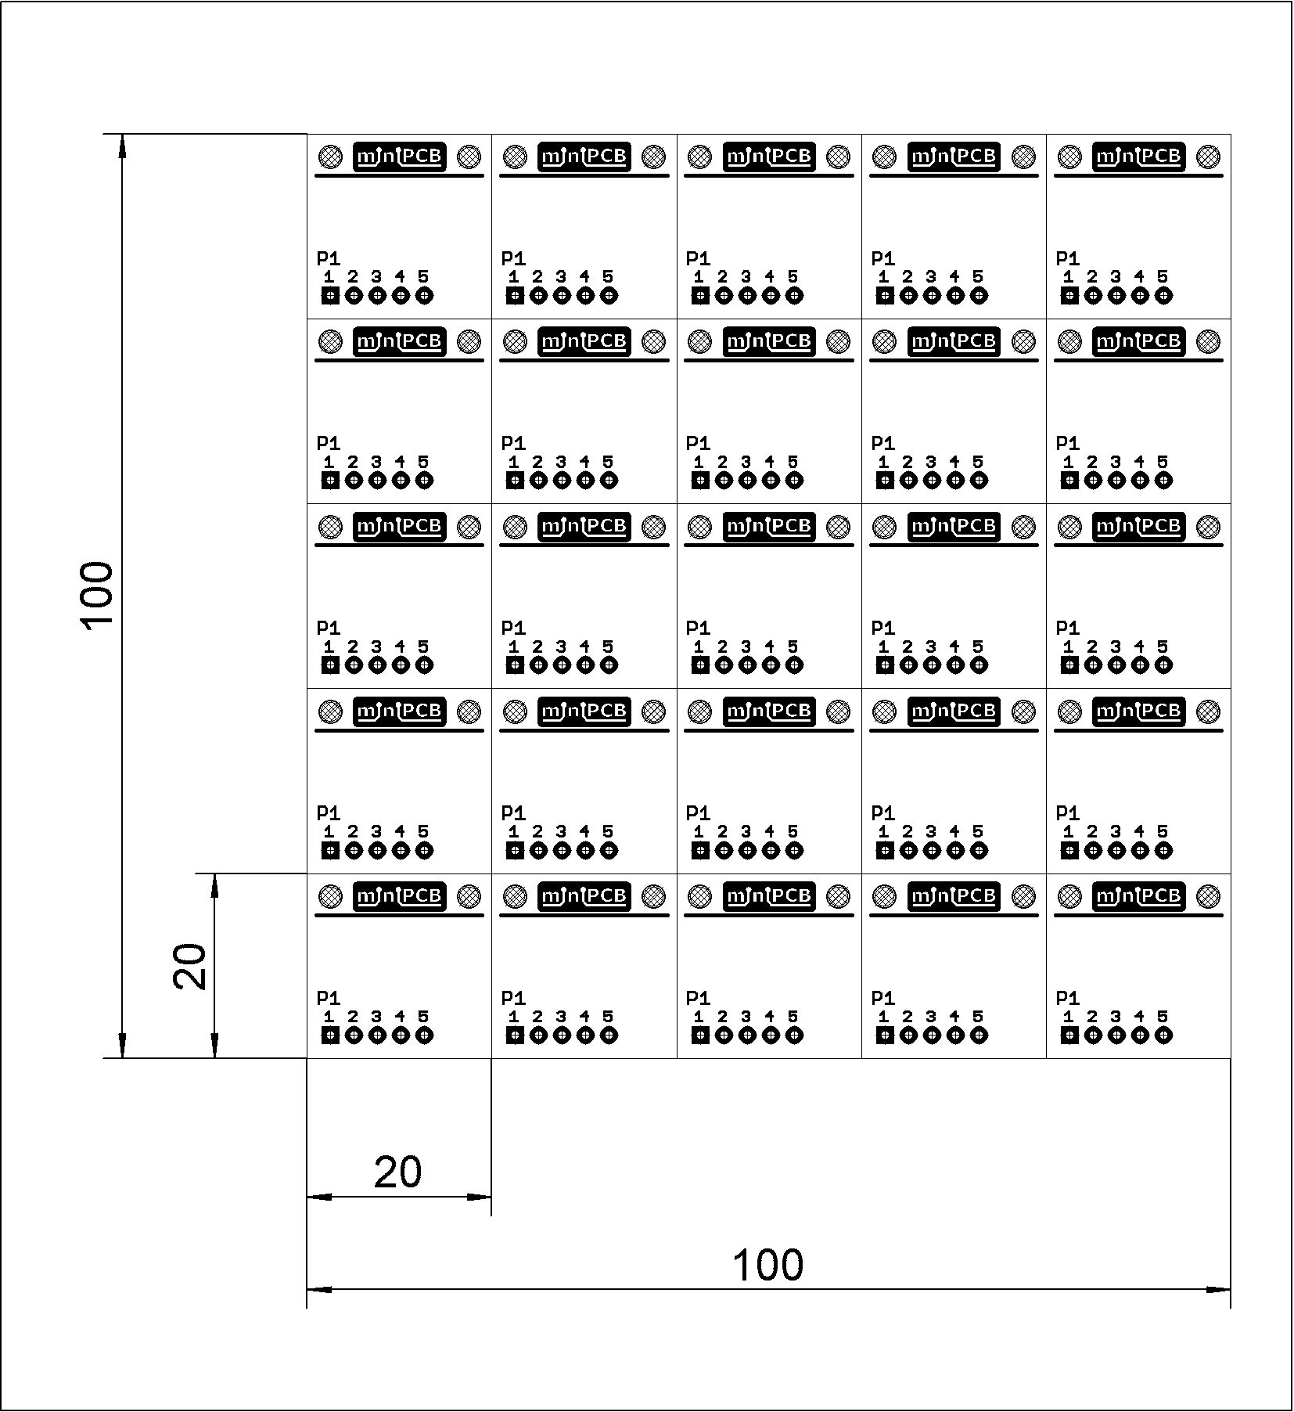

Figure – PCB20-X-05 Panel

### PCB25-X-XX Panel

Dimensions are in millimeters.

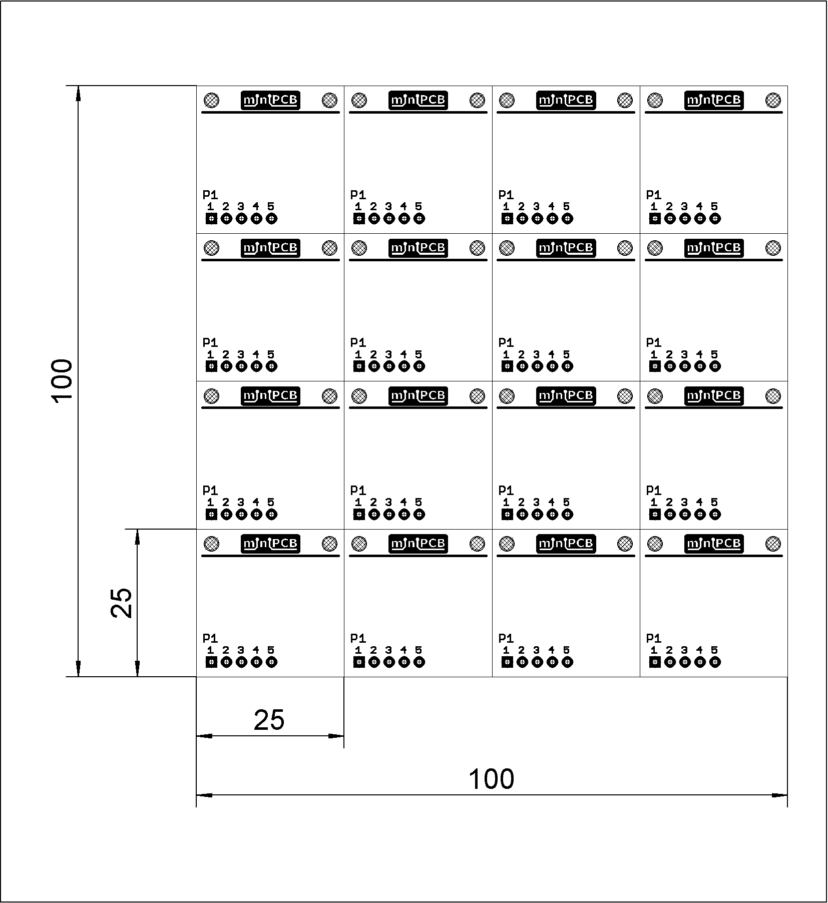

Figure – PCB25-X-05 Panel

### PCB33-X-XX Panel

Dimensions are in millimeters.

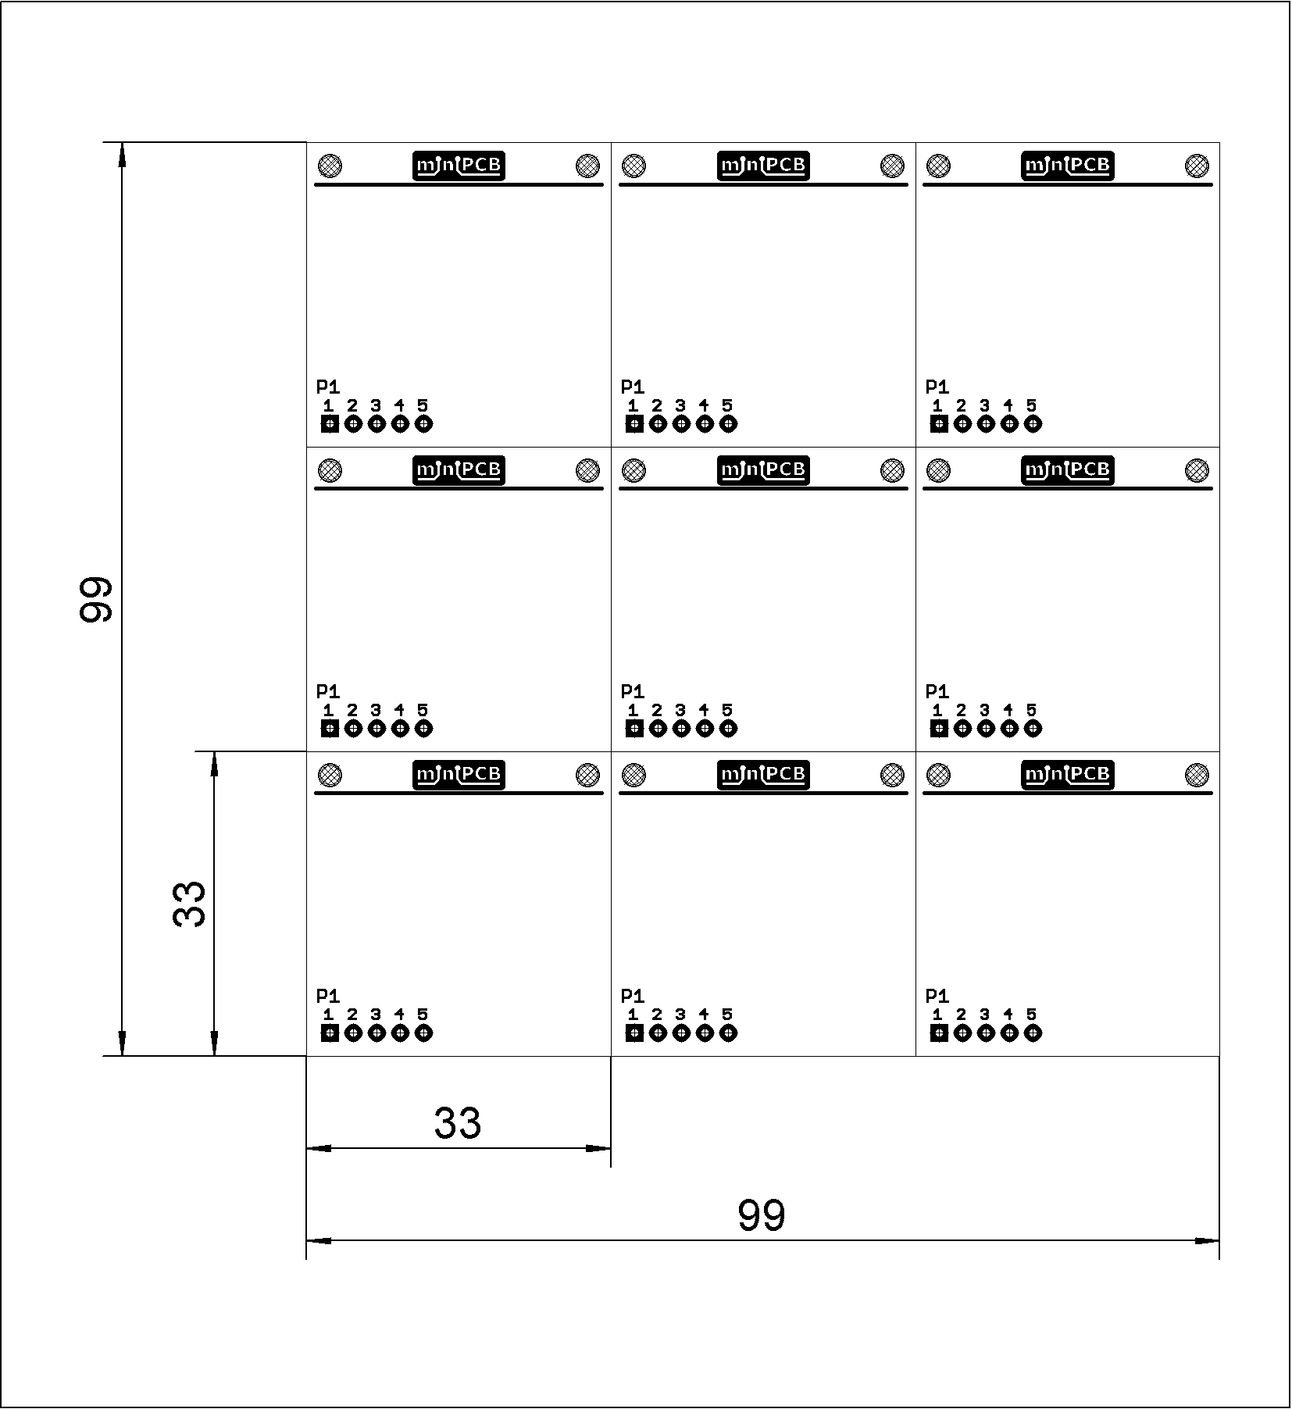

Figure – PCB33-X-05 Panel

### PCB50-X-XX Panel

Dimensions are in millimeters.

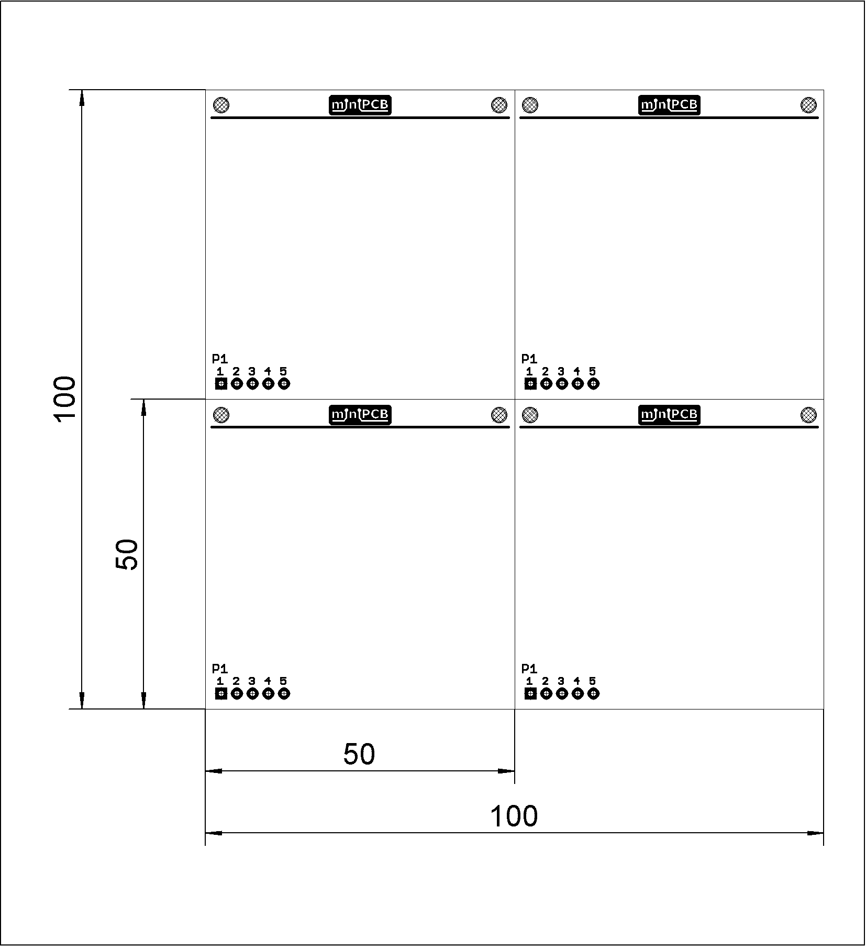

Figure – PCB50-X-05 Panel

### IDB20-X-XX Panel

Dimensions are in millimeters.

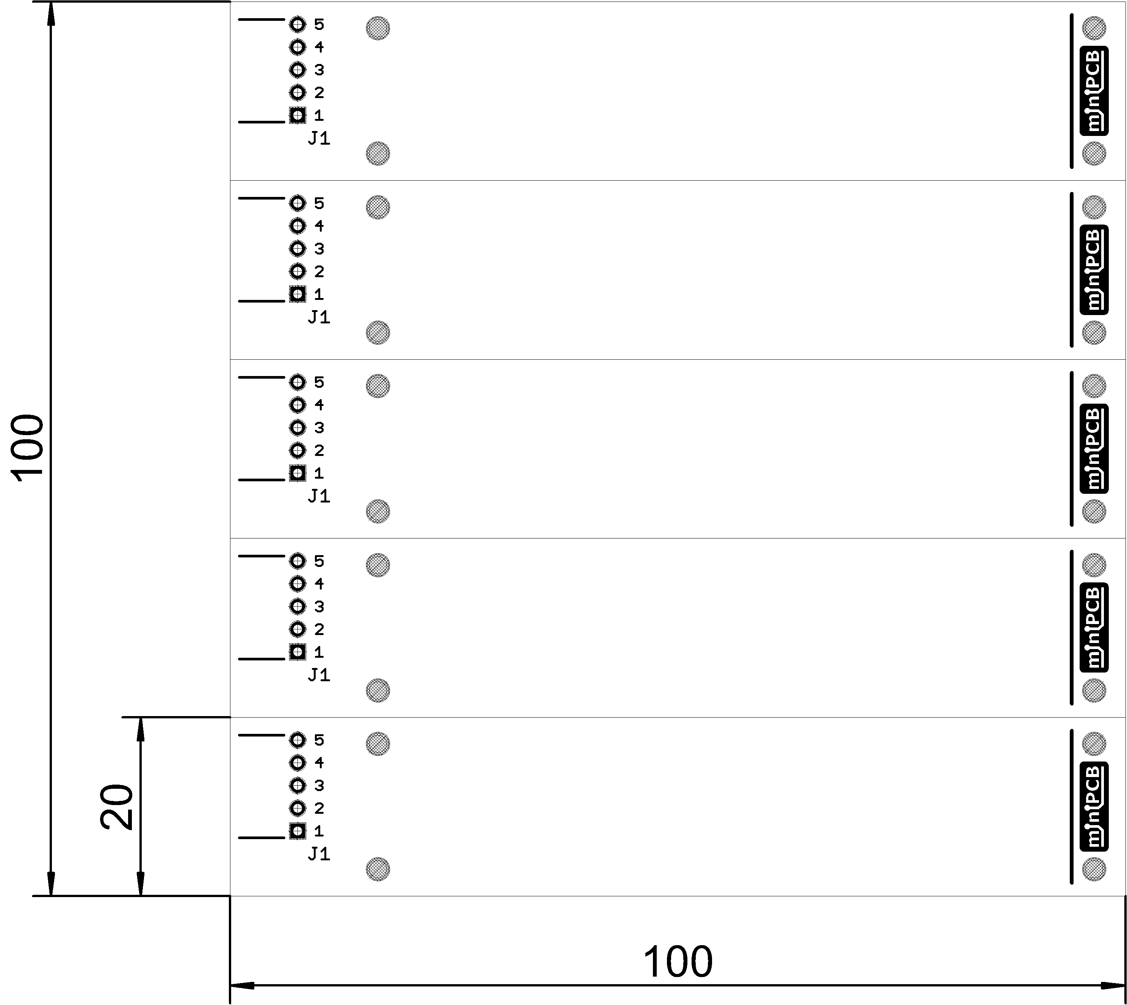

Figure – IDB20-X-05 Panel

### IDB25-X-XX Panel

Dimensions are in millimeters.

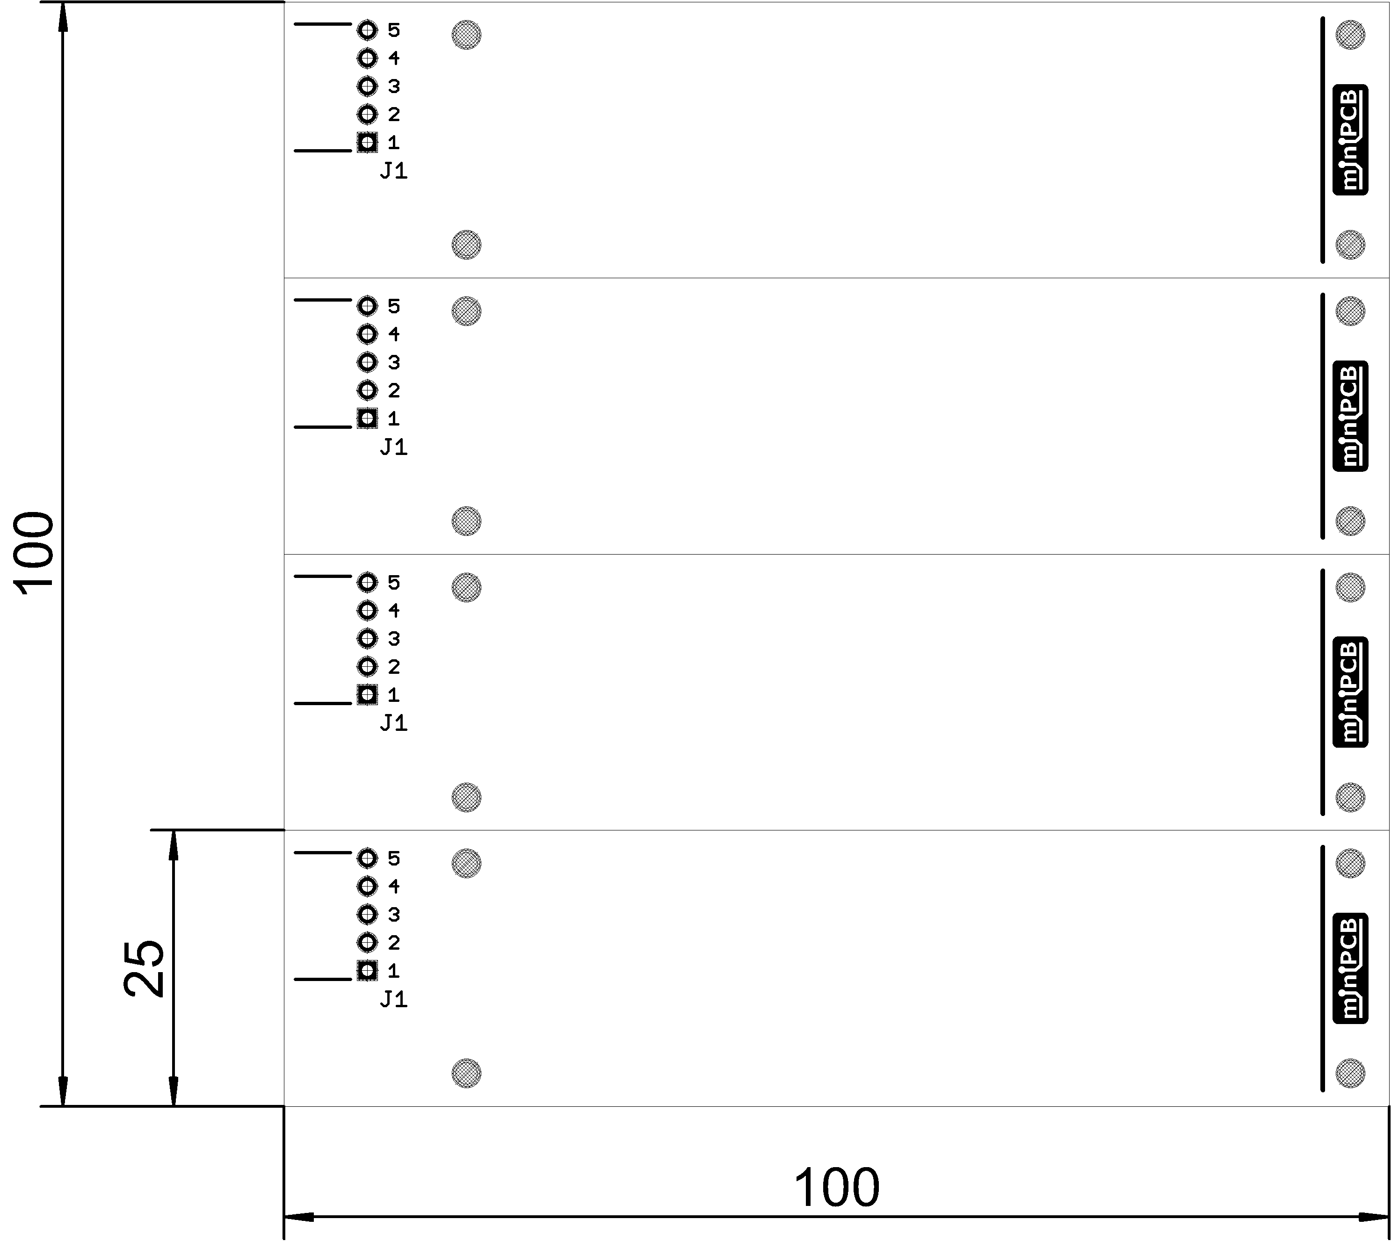

Figure – IDB25-X-05 Panel

# Change and Liability Notice

This document is subject to change without notice. While effort has been made to ensure the accuracy of the material contained within this document, Nolan Manteufel shall under no circumstances be liable for incidental or consequential damages or related expenses resulting from the use of this document.

# Trademark Notice

miniPCB is a trademark of Nolan Manteufel.

This specification does not constitute permission to use the miniPCB trademark.

|  |  |  |
| --- | --- | --- |
| WORDMARK | FIGUREMARK | FIGUREMARK |
| miniPCB™ | A picture containing drawing  Description automatically generated™ | Icon  Description automatically generated™ |

# Revision History

|  |  |  |  |
| --- | --- | --- | --- |
| REV | DESCRIPTION | ECO | DATE |
| A | Initial Release | N/A | 19AUG2022 |
| B | Added images for BIN, PIN, and IDB panels. | N/A | 20AUG2022 |
| C | Added URL to the newly created miniPCB GitHub.  Added ENGINEERING DOCUMENTATION section.  Added circuit category 12; COMMUNICATION. | N/A | 10NOV2022 |
| D | NEED TO revise IDB panel drawings.  Added miniPCB board designs (e.g. PCB50/100).  Modify pin pitch on P1 connector from 2.54 to 2.5 mm.  Added URL to miniPCB Channel on YouTube.  Added COMPONENT FOOTPRINTS section.  Added circuit category 13; GAMES. |  | DRAFT |